Developer Work Test

Work Sample 1
Using the Library Detail page design, below, create a content model and describe how you would theme it.

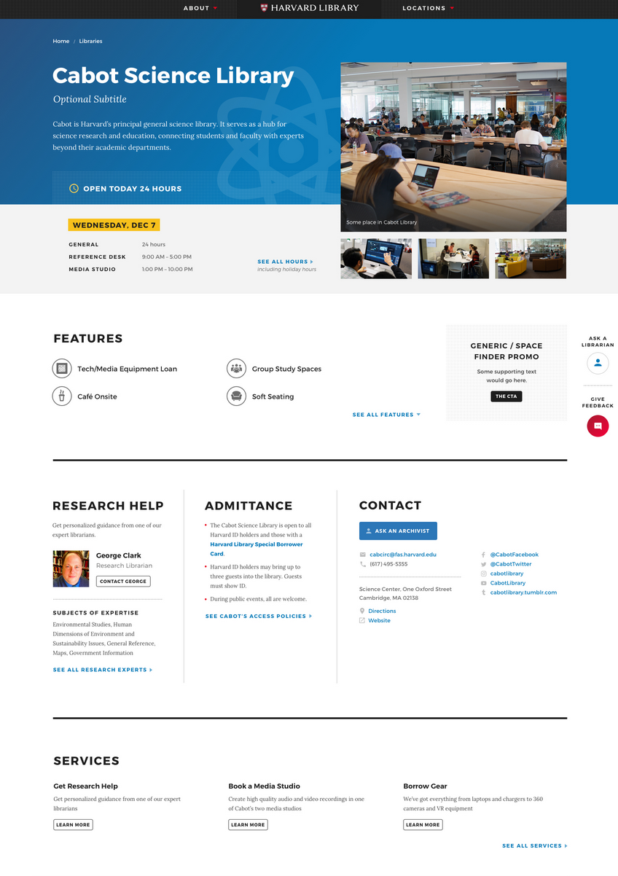

Work Sample 2
Provide an example of a Drupal module you have built that has a configuration settings page, and a class that leverages that configuration.

Optional Work Sample
Share an example of a GitHub repository from which you draw inspiration. (If you haven’t yet shared your drupal.org profile, StackExchange profile, or a GitHub profile, please provide that as well.)

